Chapter 3. Bridging Technologies
This chapter covers the following key topics:
- Transparent Bridging—
This section explains the five main processes of transparent bridging. These include Forwarding, Flooding, Filtering, Learning and Aging.
- Switching Modes—
Various switching modes such as store-and-forward, cut through and others are compared and contrasted.
- Token Ring Bridging—
Different methods exist for bridging Token Ring. This section describes your options.
- Token Ring Switching—
Token Ring switching provides many of the benefits found in Ethernet switching. This section discusses rules for Token Ring switching in a Catalyst environment
- Ethernet or Token Ring—
Some users are installing new network systems and do not know which to use. This section provides some thoughts for making the selection
- Migrating Token Ring to Ethernet—
Administrators frequently elect to replace legacy Token Ring systems with Fast Ethernet switched solutions. This section offers suggestions of things to consider in such an upgrade.
Although various internetworking devices exist for segmenting networks, Layer 2 LAN switches use bridge internetworking technology to create smaller collision domains. Chapter 2, "Segmenting LANs," discussed how bridges segment collision domains. But bridges do far more than segment collision domains: they protect networks from unwanted unicast traffic and eliminate active loops which otherwise inhibit network operations. How they do this differs for Ethernet and Token Ring networks. Ethernet employs transparent bridging to forward traffic and Spanning Tree to control loops. Token Ring typically uses a process called source-route bridging. This chapter describes transparent bridging, source-route bridging (along with some variations), and Layer 2 LAN switching. Chapter 6 covers Spanning Tree for Ethernet.

Transparent Bridging
As discussed in Chapter 2, networks are segmented to provide more bandwidth per user. Bridges provide more user bandwidth by reducing the number of devices contending for the segment bandwidth. But bridges also provide additional bandwidth by controlling data flow in a network. Bridges forward traffic only to the interface(s) that need to receive the traffic. In the case of known unicast traffic, bridges forward the traffic to a single port rather than to all ports. Why consume bandwidth on a segment where the intended destination does not exist?
Transparent bridging, defined in IEEE 802.1d documents, describes five bridging processes for determining what to do with a frame. The processes are as follows:
- Learning
- Flooding
- Filtering
- Forwarding
- Aging
Figure 3-1 illustrates the five processes involved in transparent bridging.

Figure 3-1 Transparent Bridge Flow Chart
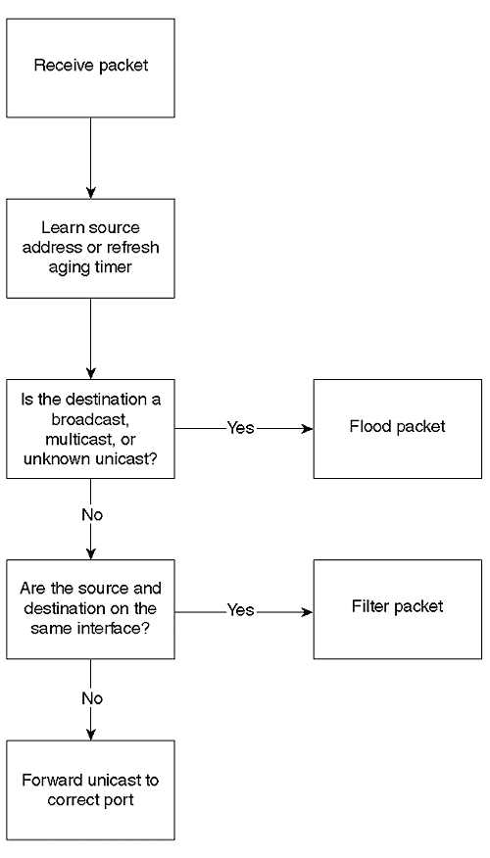
When a frame enters the transparent bridge, the bridge adds the source Ethernet MAC address (SA) and source port to its bridging table. If the source address already exists in the table, the bridge updates the aging timer. The bridge examines the destination MAC address (DA). If the DA is a broadcast, multicast, or unknown unicast, the bridge floods the frame out all bridge ports in the Spanning Tree forwarding state, except for the source port. If the destination address and source address are on the same interface, the bridge discards (filters) the frame. Otherwise, the bridge forwards the frame out the interface where the destination is known in its bridging table.
The sections that follow address in greater detail each of the five transparent bridging processes.

Learning
Each bridge has a table that records all of the workstations that the bridge knows about on every interface. Specifically, the bridge records the source MAC address and the source port in the table whenever the bridge sees a frame from a device. This is the bridge learningprocess. Bridges learn only unicast source addresses. A station never generates a frame with a broadcast or multicast source address. Bridges learn source MAC addresses in order to intelligently send data to appropriate destination segments. When the bridge receives a frame, it references the table to determine on what port the destination MAC address exists. The bridge uses the information in the table to either filter the traffic (if the source and destination are on the same interface) or to send the frame out of the appropriate interface(s).
But when a bridge is first turned on, the table contains no entries. Assume that the bridges in Figure 3-2 were all recently powered "ON," and no station had yet transmitted. Therefore, the tables in all four bridges are empty. Now assume that Station 1 transmits a unicast frame to Station 2. All the stations on that segment, including the bridge, receive the frame because of the shared media nature of the segment. Bridge A learns that Station 1 exists off of port A.1 by looking at the source address in the data link frame header. Bridge A enters the source MAC address and bridge port in the table.

Figure 3-2 Sample Bridged Network
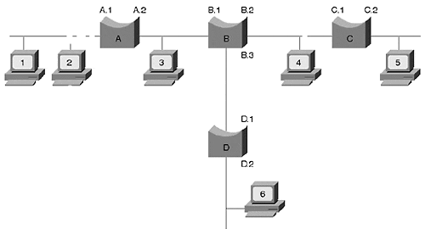

Flooding
Continuing with Figure 3-2, when Station 1 transmits, Bridge A also looks at the destination address in the data link header to see if it has an entry in the table. At this point, Bridge A only knows about Station 1. When a bridge receives a unicast frame (a frame targeting a single destination), no table entry exists for the DA, the bridge receives an unknown unicast frame.The bridging rules state that a bridge must send an unknown unicast frame out all forwarding interfaces except for the source interface. This is known as flooding. Therefore, Bridge A floods the frame out all interfaces, even though Stations 1 and 2 are on the same interface. Bridge B receives the frame and goes through the same process as Bridge A of learning and flooding. Bridge B floods the frame to Bridges C and D, and they learn and flood. Now the bridging tables look like Table 3-1. The bridges do not know about Station 2 because it did not yet transmit.

Table 3-1. Bridging Table after Flooding
Bridge Port | A.1 | A.2 | B.1 | B.2 | B.3 | C.1 | C.2 | D.1
MAC Address | 1 |  | 1 |  |  | 1 |  | 1
Still considering Figure 3-2, all the bridges in the network have an entry for Station 1 associated with an interface, pointing toward Station 1. The bridge tables indicate the relative location of a station to the port. Examining Bridge C's table, an entry for Station 1 is associated with port C.1. This does not mean Station 1 directly attaches to C.1. It merely reflects that Bridge C heard from Station 1 on this port.
In addition to flooding unknown unicast frames, legacy bridges flood two other frame types: broadcast and multicast. Many multimedia network applications generate broadcast or multicast frames that propagate throughout a bridged network (broadcast domain). As the number of participants in multimedia services increases, more broadcast/multicast frames consume network bandwidth. Chapter 13, "Multicast and Broadcast Services," discusses ways of controlling multicast and broadcast traffic flows in a Catalyst-based network.

Filtering
What happens when Station 2 in Figure 3-2 responds to Station 1? All stations on the segment off port A.1, including Bridge A, receive the frame. Bridge A learns about the presence of Station 2 and adds its MAC address to the bridge table along with the port identifier (A.1). Bridge A also looks at the destination MAC address to determine where to send the frame. Bridge A knows Station 1 and Station 2 exist on the same port. It concludes that it does not need to send the frame anywhere. Therefore, Bridge A filters the frame. Filtering occurs when the source and destination reside on the same interface. Bridge A could send the frame out other interfaces, but because this wastes bandwidth on the other segments, the bridging algorithm specifies to discard the frame. Note that only Bridge A knows about the existence of Station 2 because no frame from this station ever crossed the bridge.

Forwarding
If in Figure 3-2, Station 2 sends a frame to Station 6, the bridges flood the frame because no entry exists for Station 6. All the bridges learn Station 2's MAC address and relative location. When Station 6 responds to Station 2, Bridge D examines its bridging table and sees that to reach Station 2, it must forward the frame out interface D.1. A bridge forwards a frame when the destination address is a known unicast address (it has an entry in the bridging table) and the source and destination are on different interfaces. The frame reaches Bridge B, which forwards it out interface B.1. Bridge A receives the frame and forwards it out A.1. Only Bridges A, B, and D learn about Station 6. Table 3-2 shows the current bridge tables.

Table 3-2. Bridging Table after Forwarding
Bridge Port | A.1 | A.2 | B.1 | B.2 | B.3 | C.1 | C.2 | D.1 | D.2
MAC Address | 1 |  | 1 |  |  | 1 |  | 1
 | 2 |  | 2* |  |  | 2* |  | 2*
 |  | 6 |  |  | 6 |  |  |  | 6
*. B.1, C.1, and D.1 did not learn about Station 2 until Station 2 transmitted to Station 6.

Aging
When a bridge learns a source address, it time stamps the entry. Every time the bridge sees a frame from that source, the bridge updates the timestamp. If the bridge does not hear from that source before an aging timerexpires, the bridge removes the entry from the table. The network administrator can modify the aging timer from the default of five minutes.
Why remove an entry? Bridges have a finite amount of memory, limiting the number of addresses it can remember in its bridging tables. For example, higher end bridges can remember upwards of 16,000 addresses, while some of the lower-end units may remember as few as 4,096. But what happens if all 16,000 spaces are full in a bridge, but there are 16,001 devices? The bridge floods all frames from station 16,001 until an opening in the bridge table allows the bridge to learn about the station. Entries become available whenever the aging timer expires for an address. The aging timer helps to limit flooding by remembering the most active stations in the network. If you have fewer devices than the bridge table size, you could increase the aging timer. This causes the bridge to remember the station longer and reduces flooding.
Bridges also use aging to accommodate station moves. In Table 3-2, the bridges know the location of Stations 1, 2, and 6. If you move Station 6 to another location, devices may not be able to reach Station 6. For example, if Station 6 relocates to C.2 and Station 1 transmits to Station 6, the frame never reaches Station 6. Bridge A forwards the frame to Bridge B, but Bridge B still thinks Station 6 is located on port B.3. Aging allows the bridges to "forget" Station 6's entry. After Bridge B ages the Station 6 entry, Bridge B floods the frames destined to Station 6 until Bridge B learns the new location. On the other hand, if Station 6 initiates the transmission to Station 1, then the bridges immediately learn the new location of Station 6. If you set the aging timer to a high value, this may cause reachability issues in stations within the network before the timer expires.
The Catalyst screen capture in Example 3-1 shows a bridge table example. This Catalyst knows about nine devices (see bolded line) on nine interfaces. Each Catalyst learns about each device on one and only one interface.

Example 3-1 Catalyst 5000 Bridging Table
Console> (enable) show cam dynamic VLAN Dest MAC/Route Des Destination Ports or VCs ---- ------------------ ---------------------------------------------------- 2 00-90-ab-16-60-20 3/4 1 00-90-ab-16-b0-20 3/10 2 00-90-ab-16-4c-20 3/2 1 00-60-97-8f-4f-86 3/23 1 00-10-07-3b-5b-00 3/17 1 00-90-ab-16-50-20 3/91 3 00-90-ab-16-54-20 3/1 1 00-90-92-bf-74-00 3/18 1 00-90-ab-15-d0-10 3/3 Total Matching CAM Entries Displayed = 9 Console> (enable)
The bridge tables discussed so far contain two columns: the MAC address and the relative port location. These are seen in columns two and three in Example 3-1, respectively. But this table has an additional column. The first column indicates the VLAN to which the MAC address belongs. A MAC address belongs to only one VLAN at a time. Chapter 5, "VLANs," describes VLANs and why this is so.

Switching Modes
Chapter 2 discusses the differences between a bridge and a switch. Cisco identifies the Catalyst as a LAN switch; a switch is a more complex bridge. The switch can be configured to behave as multiple bridges by defining internal virtual bridges (i.e., VLANs). Each virtual bridge defines a new broadcast domain because no internal connection exists between them. Broadcasts for one virtual bridge are not seen by any other. Only routers (either external or internal) should connect broadcast domains together. Using a bridge to interconnect broadcast domains merges the domains and creates one giant domain. This defeats the reason for having individual broadcast domains in the first place.
Switches make forwarding decisions the same as a transparent bridge. But vendors have different switching modes available to determine when to switch a frame. Three modes in particular dominate the industry: store-and-forward, cut-through, and fragment-free. Figure 3-3 illustrates the trigger point for the three methods.

Figure 3-3 Switching Mode Trigger Points
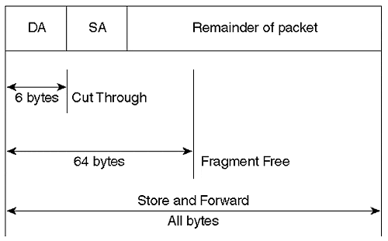
Each has advantages and trade offs, discussed in the sections that follow. As a result of the different trigger points, the effective differences between the modes are in error handling and latency. Table 3-3 compares the approaches and shows which members of the Catalyst family use the available modes. The table summarizes how each mode handles frames containing errors, and the associated latency characteristics.

Table 3-3. Switching Mode Comparison
Switching Mode | Errored Frame Handling | Latency | CAT Member*
Store-and-forward | Drop* | Variable | 5500, 5000,  3920, 3900,  3000, 2900,  1900, 2820,  2600, 6000
Cut-through | Forwards | Low-fixed | 3920, 3900,  3000, 2600
Fragment-free | Drops if error detected in first 64 octets | Moderate fixed | 3000, 2820,  1900
*. Note that when a model supports more than one switching mode, adaptive cut-through may be available. Check model specifics to confirm.
One of the objectives of switching is to provide more bandwidth to the user. Each port on a switch defines a new collision domain that offers full media bandwidth. If only one station attaches to an interface, that station has full dedicated bandwidth and does not need to share it with any other device. All the switching modes defined in the sections that follow support the dedicated bandwidth aspect of switching.
Tip
To determine the best mode for your network, consider the latency requirements for your applications and your network reliability. Do your network components or cabling infrastructure generate errors? If so, fix your network problems and use store-and-forward. Can your applications tolerate the additional latency of store-and-forward switching? If not, use cut-through switching. Note that you must use store-and-forward with the Cat 5000 and 6000 family of switches. This is acceptable because latency is rarely an issue, especially with high-speed links and processors and modern windowing protocols. Finally, if the source and destination segments are different media types, you must use store-and-forward mode.

Store-and-Forward Switching
The store-and-forward switching mode receives the entire frame before beginning the switching process. When it receives the complete frame, the switch examines it for the source and destination addresses and any errors it may contain, and then it possibly applies any special filters created by the network administrator to modify the default forwarding behavior. If the switch observes any errors in the frame, it is discarded, preventing errored frames from consuming bandwidth on the destination segment. If your network experiences a high rate of frame alignment or FCS errors, the store-and-forward switching mode may be best. The absolute best solution is to fix the cause of the errors. Using store-and-forward in this case is simply a bandage. It should not be the fix.
If your source and destination segments use different media, then you must use this mode. Different media often have issues when transferring data. The section "Source-Route Translation Bridging" discusses some of these issues. Store-and-forward mode is necessary to resolve this problem in a bridged environment.
Because the switch must receive the entire frame before it can start to forward, transfer latency varies based on frame size. In a 10BaseT network, for example, the minimum frame, 64 octets, takes 51.2 microseconds to receive. At the other extreme, a 1518 octet frame requires at least 1.2 milliseconds. Latency for 100BaseX (Fast Ethernet) networks is one-tenth the 10BaseT numbers.

Cut-Through Switching
Cut-through mode enables a switch to start the forwarding process as soon as it receives the destination address. This reduces latency to the time necessary to receive the six octet destination address: 4.8 microseconds. But cut-through cannot check for errored frames before it forwards the frame. Errored frames pass through the switch, consequently wasting bandwidth; the receiving device discards errored frames.
As network and internal processor speeds increase, the latency issues become less relevant. In high speed environments, the time to receive and process a frame reduces significantly, minimizing advantages of cut-through mode. Store-and-forward, therefore, is an attractive choice for most networks.
Some switches support both cut-through and store-and-forward mode. Such switches usually contain a third mode called adaptive cut-through. These multimodal switches use cut-through as the default switching mode and selectively activate store-and-forward. The switches monitor the frame as it passes through looking for errors. Although the switch cannot stop an errored frame, it counts how many it sees. If the switch observes that too many frames contain errors, the switch automatically activates the store-and-forward mode. This is often known as adaptive cut-through. It has the advantage of providing low latency while the network operates well, while providing automatic protection for the outbound segment if the inbound segment experiences problems.

Fragment-Free Switching
Another alternative offers some of the advantages of cut-through and store-and-forward switching. Fragment-free switching behaves like cut-through in that it does not wait for an entire frame before forwarding. Rather, fragment-free forwards a frame after it receives the first 64 octets of the frame (this is longer than the six bytes for cut-through and therefore has higher latency). Fragment-free switching protects the destination segment from fragments, an artifact of half-duplex Ethernet collisions. In a correctly designed Ethernet system, devices detect a collision before the source finishes its transmission of the 64-octet frame (this is driven by the slotTime described in Chapter 1). When a collision occurs, a fragment (a frame less than 64 octets long) is created. This is a useless Ethernet frame, and in the store-and-forward mode, it is discarded by the switch. In contrast, a cut-through switch forwards the fragment if at least a destination address exists. Because collisions must occur during the first 64 octets, and because most frame errors will show up in these octets, the fragment-free mode can detect most bad frames and discard them rather than forward them. Fragment-free has a higher latency than cut-through, however, because it must wait for an additional 58 octets before forwarding the frame. As described in the section on cut-through switching, the advantages of fragment-free switching are minimal given the higher network speeds and faster switch processors.

Token Ring Bridging
When IBM introduced Token Ring, they described an alternative bridging technique called source-route bridging. Although transparent bridging, as discussed in the previous section, works in a Token Ring environment, IBM networks have unique situations in which transparent bridging creates some obstacles. An example is shown in a later section, "Source-Route Transparent Bridging." Source-route bridging, on the other hand, overcomes these limitations.
Many networks have a combination of transparent and source-route bridged devices. The industry developed source-route transparent bridging for hybrid networks, allowing them to coexist. However, the source-route devices cannot inherently communicate with the transparent devices. Source-route translation bridging, yet another bridging method, offers some hope of mixed media communication. The sections that follow present all three Token Ring bridging methods (source-route, source-route transparent, and source-route translational). The switching aspects of Token Ring networks are described later in the section "Token Ring Switching."

Source-Route Bridging
In a Token Ring environment, rings interconnect with bridges. Each ring and bridge has a numeric identifier. The network administrator assigns the values and must follow several rules. Typically, each ring is uniquely identified within the bridged network with a value between 1 and 4095. (It is possible to have duplicate ring numbers, as long as the rings do not attach to the same bridge.) Valid bridge identifiers include 1 through 15 and must be unique to the local and target rings. A ring cannot have two bridges with the same bridge number. Source devices use ring and bridge numbers to specify the path that the frame will travel through the bridged network. Figure 3-4 illustrates a source-route bridging (SRB) network with several attached workstations.

Figure 3-4 A Source-Route Bridged Network
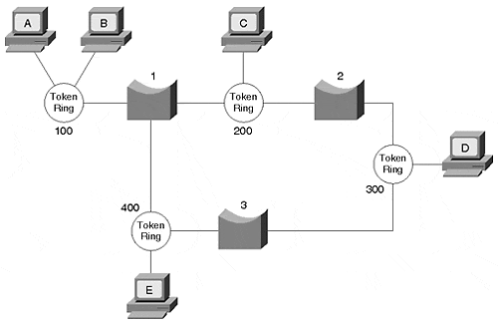
When Station A wants to communicate with Station B, Station A first sends a test frame to determine whether the destination is on the same ring as the source. If Station B responds to the test frame, the source knows that they are both on the same ring. The two stations communicate without involving any Token Ring bridges.
If, however, the source receives no response to the test frame, the source attempts to reach the destination on other rings. But the frame must now traverse a bridge. In order to pass through a bridge, the frame includes a routing information field (RIF). One bit in the frame header signals bridges that a RIF is present and needs to be examined by the bridge. This bit, called the routing information indicator (RII), is set to "zero" when the source and destination are on the same ring; otherwise, it is set to "one."
Most importantly, the RIF tells the bridge how to send the frame toward the destination. When the source first attempts to contact the destination, the RIF is empty because the source does not know any path to the destination. To complete the RIF, the source sends an all routes explorer (ARE) frame (it is also possible to use something called a Spanning Tree Explorer [STE]). The ARE passes through all bridges and all rings. As it passes through a bridge, the bridge inserts the local ring and bridge number into the RIF. If in Figure 3-5, Station A sends an ARE to find the best path to reach Station D, Station D will receive two AREs. The RIFs look like the following:

Ring100 - Bridge1 - Ring200 - Bridge2 - Ring300
Ring100 - Bridge1 - Ring400 - Bridge3 - Ring300

Each ring in the network, except for ring 100, see two AREs. For example, the stations on ring 200 receive two AREs that look like the following:

Ring100-Bridge1-Ring200
Ring100-Bridge1-Ring400-Bridge3-Ring300-Bridge2-Ring200

The AREs on ring 200 are useless for this session and unnecessarily consume bandwidth. As the Token Ring network gets more complex with many rings interconnected in a mesh design, the quantity of AREs in the network increases dramatically.
Note
A Catalyst feature, all routes explorer reduction, ensures that AREs don't overwhelm the network. It conserves bandwidth by reducing the number of explorer frames in the network.

Station D returns every ARE it receives to the source. The source uses the responses to determine the best path to the destination. What is the best path? The SRB standard does not specify which response to use, but it does provide some recommendations. The source could do any of the following:
- Use the first response it receives
- Use the path with the fewest hops
- Use the path with the largest MTU
- Use a combination of criteria
- Most Token Ring implementations use the first option.
Now that Station A knows how to reach Station D, Station A transmits each frame as a specifically routed frame where the RIF specifies the ring/bridge hops to the destination. When a bridge receives the frame, the bridge examines the RIF to determine if it has any responsibility to forward the frame. If more than one bridge attaches to ring 100, only one of them forwards the specifically routed frame. The other bridge(s) discard it. Station D uses the information in the RIF when it transmits back to Station A. Station D creates a frame with the RIF completed in reverse. The source and destination use the same path in both directions.
Note that transparent bridging differs from SRB in significant ways. First, in SRB, the source device determines what path the frame must follow to reach the destination. In transparent bridging, the bridge determines the path. Secondly, the information used to determine the path differs. SRB uses bridge/ring identifiers, and transparent bridging uses destination MAC addresses.

Source-Route Transparent Bridging
Although many Token Ring networks start out as homogenous systems, transparently bridged Ethernet works its way into many of these networks. As a result, network administrators face hybrid systems and support source-route bridged devices and transparently bridged devices. Unfortunately, the source-route bridged devices cannot communicate with the transparently bridged Ethernet devices. Non-source-routed devices do not understand RIFs, SREs, or any other such frames. To further confuse the issue, some Token Ring protocols run in transparent mode, a typically Ethernet process.
Note
Source-route translational bridging (SR/TLB), described in the next section, can overcome some of the limitations of source-route transparent bridging (SRT). The best solution, though, is to use a router to interconnect routed protocols residing on mixed media.

Source-route transparent bridging (SRT) supports both source-route and transparent bridging for Token Ring devices. The SRT bridge uses the RII bit to determine the correct bridging mode. If the bridge sees a frame with the RII set to "zero," the SRT bridge treats the frame using transparent bridging methods. It looks at the destination MAC address and determines whether to forward, flood, or filter the frame. If the frame contains a RIF (the RII bit set to "one"), the bridge initiates source-route bridging and uses the RIF to forward the frame. Table 3-4 compares how SRT and SRB bridges react to RII values

Table 3-4. SRT and SRB Responses to RII
RII Value | SRB | SRT
zero | Drop frame | Transparently bridge frame
one | Source-route frame | Source-route frame
This behavior causes problems in some IBM environments. Whenever an IBM Token Ring attached device wants to connect to another, it first issues a test frame to see whether the destination resides on the same ring as the source. If the source receives no response, it sends an SRB explorer frame.
The SRT deficiency occurs with the test frame. The source intends for the test frame to remain local to its ring and sets the RII to "zero." An RII set to "zero," however, signals the SRT bridge to transparently bridge the frame. The bridge floods the frame to all rings. After the test frame reaches the destination, the source and destination workstations communicate using transparent bridging methods as if they both reside on the same ring. Although this is functional, transparent bridging does not take advantage of parallel paths like source-route bridging can. Administrators often create parallel Token Ring backbones to distribute traffic and not overburden any single link. But transparent bridging selects a single path and does not use another link unless the primary link fails. (This is an aspect of the Spanning-Tree Protocol described in Chapter 6, "Understanding Spanning Tree," and Chapter 7, "Advanced Spanning Tree." ) Therefore, all the traffic passes through the same links, increasing the load on one while another remains unused. This defeats the intent of the parallel Token Rings.
Another IBM operational aspect makes SRT unsuitable. To achieve high levels of service availability, some administrators install redundant devices, such as a 3745 controller, as illustrated in Figure 3-5.

Figure 3-5 Redundant Token Ring Controllers
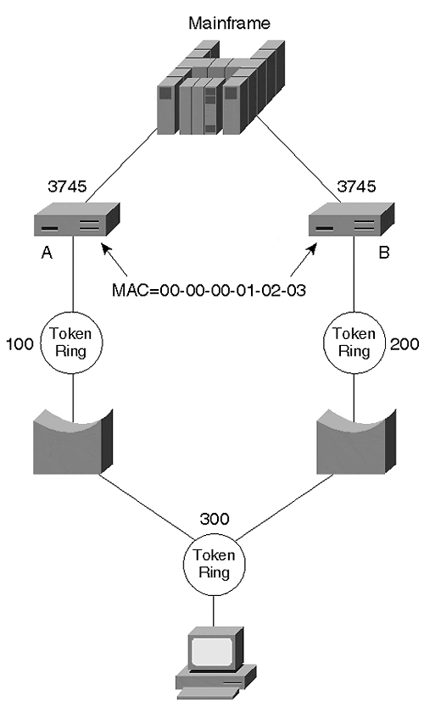
The redundant controllers use the same MAC address (00-00-00-01-02-03) to simplify workstation configuration; otherwise, multiple entries need to be entered. If the primary unit fails, the workstation needs to resolve the logical address to the new MAC address of the backup unit. By having duplicate MAC addresses, fully automatic recovery is available without needing to resolve a new address.
Duplicate MAC addresses within a transparently bridged network confuses bridging tables, however. A bridge table can have only one entry for a MAC address; a station cannot appear on two interfaces. Otherwise, if a device sends a frame to the MAC address for Controller A in Figure 3-5, how can the transparent bridge know whether to send the frame to Controller A or Controller B? Both have the same MAC address, but only one can exist in the bridging table. Therefore, the intended resiliency feature will not work in the source-route transparent bridge mode. When using the resiliency feature, configure the Token Ring Concentrator Relay Function (TrCRF) for source-route bridging. The TrCRF defines ports to a common ring. The TrCRF is discussed later in the chapter in the "Token Ring Switching" section.

Source-Route Translational Bridging
Unfortunately, not all networks are homogenous. They may contain a mixture of Ethernet and Token Ring access methods. How would you attach a Token Ring network to an Ethernet such as the one shown in Figure 3-6?

Figure 3-6 Bridging Mixed Media Access Networks
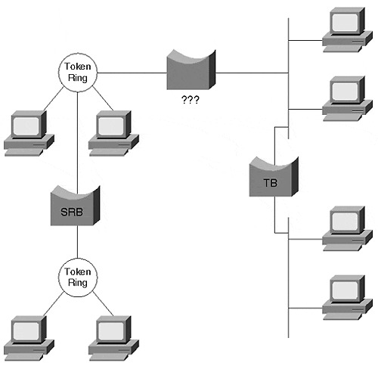
Several obstacles prevent devices on the two networks from communicating with each other. Some of the obstacles include the following:
- MAC address format
- MAC address representation in the protocol field
- LLC and Ethernet framing
- Routing information field translation
- MTU size mismatch
Translational bridging helps to resolve these issues, allowing the devices to communicate. But no standard exists for translational bridging, leaving a number of implementation details to the vendor. The following sections discuss in more detail each listed limitation. The sections provide a technical and a practical explanation of why transparent bridging might not be the best option.

MAC Address Format
When devices transmit frames, the bit sequence varies depending on the access method. An Ethernet frame has a format of DA|SA|Type|Data. But when the frame enters the media, which bit goes first? In Ethernet, the least significant bit of each octet does. Consider, for example, a hexadecimal value of 0x6A. In binary, this looks like: 0110 1010 with the most significant bit (MSB) on the left and the least significant bit (LSB) on the right. Ethernet transmits the LSB first. This is called the canonical address format. Token Ring and FDDI use a non-canonical format, transmitting the MSB first and the LSB last. The binary stream looks like 0101 0110 and has a hex value of 0x56. A translational bridge sequences the bits appropriately for the receiving network type so that the devices will see the correct MAC address. A canonical source MAC address of 0C-00-01-38-73-0B sent onto a Token Ring segment must have the address transmitted in non-canonical format as 30-00-80-1C-CE-D0. If the bridge does not perform address translation, the Token Ring device will respond to the wrong MAC address.

Embedded Address Format
Similarly, MAC address translation may need to occur at Layer 3. Some protocols embed the MAC address in the Layer 3 protocol header. IPX for example, uses a logical IPX address format comprising a network number and MAC address. In TCP/IP, the address resolution protocol (ARP) includes the source and destination MAC address in the frame as part of the IP protocol header. Other protocols that embed MAC addresses in the Layer 3 header include DECnet Phase IV, AppleTalk, Banyan VINES, and XNS. Many of these protocols respond to the MAC address contained in the Layer 3 header, not the data link layer. A translational bridge must therefore be intelligent and protocol-aware to know when to modify the Layer 3 information to correctly represent the MAC address. This is, of course, an activity normally relegated to a router, which operates at Layer 3. If a new protocol that needs translational bridging is added to the network, the bridge must be updated to know about the translation tasks. Translational bridging must keep abreast of industry protocols to allow inter-communication between the differently bridged devices.

LLC and Ethernet Frame Differences
Ethernet-formatted frames use a DA|SA|Protocol_Type format that, when bridged onto an IEEE 802 formatted network, presents the problem of what to do with the Protocol_Type value. IEEE 802 headers do not have a provision for the Protocol_Type value. The SNAP encapsulation approach was devised to carry the Protocol_Type value across IEEE 802-based networks. Figure 3-7 illustrates a translation from Ethernet to Token Ring SNAP.

Figure 3-7 Frame Translation from Ethernet to Token Ring SNAP
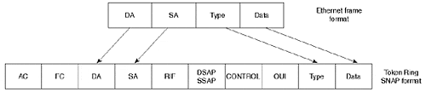
The frame fields illustrated in Figure 3-7 are as follows:
AC (access control)
FC (frame control)
DA (destination MAC address)
SA (source MAC address)
RIF (routing information field)
DSAP (destination service access point)
SSAP (source service access point)
Control (LLC control)
OUI (Organizational Unique Identifier—vendor ID)
Type (protocol type value)

RIF Interpretation
When connecting source-route devices to transparent devices, another issue involves the routing information field. The RIF is absent from transparent devices but is vital to the Token Ring bridging process. How then does a source-route bridged device specify a path to a transparently bridged device?
A translational bridge assigns a ring number to the transparent segment. To an SRB device, it appears that the destination device resides on a source-routed segment. To the transparent device, the SRB device appears to attach to a transparent segment. The translational bridge keeps a source-routing table to reach the Token Ring MAC address. When a transparent device transmits a frame to the Token Ring device, the bridge looks at the destination MAC address, finds a source-route entry for that address, and creates a frame with a completed RIF.

MTU Size
Ethernet, Token Ring, and FDDI support different frame sizes. Table 3-5 lists the minimum and maximum frame sizes for these media access methods.

Table 3-5. Frame Size Comparison
Media Access Method | Minimum Frame Size (Octets) | Maximum Frame Size (Octets)
Ethernet | 64 | 1518
Token Ring (4 Mbps) | 21 | 4511
Token Ring (16 Mbps) | 21 | 17839
FDDI | 28 | 4500
A frame from one network type cannot violate the frame size constraints of the destination network. If an FDDI device transmits to an Ethernet device, it must not create a frame over 1518 octets or under 64 octets. Otherwise, the bridge must drop the frame. Translational bridges attempt to adjust the frame size to accommodate the maximum transmission unit (MTU) mismatch. Specifically, a translational bridge may fragment an IP frame if the incoming frame exceeds the MTU of the outbound segment. Routers normally perform fragmentation because it is a Layer 3 process. Translational bridges that perform fragmentation actually perform a part of the router's responsibilities.
Note, however, that fragmentation is an IP process. Other protocols do not have fragmentation, so the source must create frames appropriately sized for the segment with the smallest MTU. In order for these protocols to work correctly, they exercise MTU discovery, which allows the stations to determine the largest allowed frame for the path(s) between the source and destination devices. This option exists in IP, too, and is preferred over fragmentation.

Catalyst and Translational Bridging
Catalyst Token Ring modules do not provide translational bridging. An external Cisco router or the Route Switch Module (RSM) operating in a bridging mode, however, does support translational bridging. The most reliable interconnection method between different access types, however, is routing. Because routers are protocol-aware, they reliably translate all necessary elements of the frame when converting from Token Ring to other network types.

Token Ring Switching
Token Ring switching offers many of the advantages found in switched Ethernet networks. Most notably, it offers more bandwidth by reducing the size of the Token Ring domain. In the extreme case, the smallest Token Ring domain is a dedicated workstation on a switch port. Catalyst Token Ring switching creates two virtual entities: the Token Ring Concentrator Relay Function (TrCRF) and the Token Ring Bridge Relay Function (TrBRF). Together, these functions form a switched Token Ring network with smaller token domains.
Source-route switching described in the later section "Source-Route Switching" provides a service within the TrCRF for transferring frames between ports within a ring, or to the TrBRF to transfer to another TrCRF.
Another Catalyst Token Ring feature protects you from misconfiguring the system with a duplicate ring on another Catalyst. This is an erroneous configuration, which, if actually performed, could prevent your Token Ring network from operating correctly. DRiP is described in the later section "Duplicate Ring Protocol (DRiP)."

Token Ring Concentrator Relay Function (TrCRF)
In Token Ring networks, multistation access units (MAUs) interconnect workstations to form a physical star topology. The MAU, a type of concentrator, maintains ring functionality and passes tokens and frames among all stations attached to the ring. All the stations attached to the MAU share the same token and bandwidth.
In the Catalyst, the network administrator assigns ports to a virtual concentrator called a Token Ring Concentrator Relay Function (TrCRF). All the ports assigned to a TrCRF belong to the same ring number. However, the workstations attached to each port experience full media bandwidth and have no perception that other stations share the ring.
The TrCRF defines the port to ring number association. The Catalyst in Figure 3-8 defines four TrCRFs to interconnect fourteen ports. (A port is a member of one and only one TrCRF.)

Figure 3-8 Defining TrCRFs to Interconnect Ports
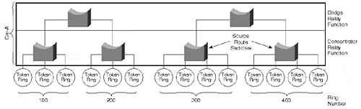
In general, a TrCRF can reside in only one Catalyst and cannot span outside of a Catalyst. This is called an undistributed TrCRF. An exception to this, the default TrCRF, spans Catalysts and is referred to as a distributed TrCRF. (A backup TrCRF may also span Catalysts.) The default TrCRF enables all Token Ring ports to belong to a common TrCRF without any administrator intervention. Users can attach to any Token Ring port and communicate with any other station in the distributed TrCRF network. The default TrCRF behaves like a giant ring extending across all Catalysts and provides the "plug and play" capability of the Catalyst in Token Ring networks.
When configuring a TrCRF, you must define the ring and VLAN numbers, and you must associate it with an existing parent TrBRF (TrBRFs are discussed in the next section). The parent TrBRF is assigned a VLAN number and is the identifier used to associate the TrCRF to the TrBRF. In addition, you may define whether the TrCRF will operate in the SRB or SRT mode. If left unspecified, the TrCRF will operate in SRB mode.

Token Ring Bridge Relay Function (TrBRF)
The Token Ring Bridge Relay Function (TrBRF) acts like a multiport bridge and interconnects rings. The TrBRF defines the TrCRF-to-bridge association. A TrCRF belongs to only one parent TrBRF, but multiple TrCRFs may attach to a parent bridge. Figure 3-8, for example, shows more than one TrCRF attached to a TrBRF. The TrCRFs interconnect through the TrBRF the same as rings do through the source-route bridges and source-route transparent bridges previously described. Unlike the TrCRF, the TrBRF can span between Catalysts, as shown in Figure 3-9. This allows TrCRFs on various Catalysts to belong to the same bridge

Figure 3-9 TrBRF Extending Across Catalysts
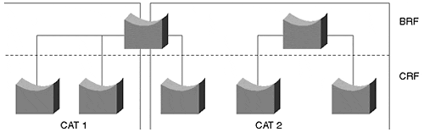
Enabling a TrBRF requires a bridge and VLAN number. The TrBRF's VLAN number is paired with the TrCRF VLAN number to create the parent-to-child relationship. Because a TrCRF must associate with a parent TrBRF, the default TrCRF belongs to a default TrBRF. When enabling Token Ring switching with a non-default TrCRF and TrBRF, you must first configure the TrBRF, then the TrCRF, and finally, group ports to TrCRFs. Referring to Figure 3-9, you would do the following:
- Configure the TrBRF at the top of the drawing. To do this, you define the bridge number and the VLAN number as in the following:

- Console> (enable) set vlan 100 type trbrf bridge

- Work down the figure to the TrCRF(s). Create the TrCRF, specifying the VLAN number, the ring number, the bridge type, and parent TrBRF. Here is an example:

- Console> (enable) set vlan 110 type trcrf parent 100 ring 10

- After creating the TrCRF, associate ports to the correct TrCRF.

Source-Route Switching
Source-route switching describes the mechanism of bridging Token Ring traffic. The modes are determined based on the location of the source and destination devices relative to the bridging function. The source-route switch (SRS) decides whether to transparently bridge a frame within a TrCRF or to source-route bridge to another TrCRF. When a station on a switch port transmits to another station residing on a different port but belonging to the same TrCRF, the SRS forwards the frame based on the destination MAC address. The SRS learns source MAC addresses and makes forwarding decisions the same as a transparent bridge. However, if the source and destination are on different rings, the source creates a frame with a RIF. The SRS examines the RIF and passes the frame to the bridge relay function for forwarding.
Although this sounds like a source-route bridge, a significant difference distinguishes an SRS from an SRB. When a station transmits an ARE, an SRB modifies the RIF to indicate ring/bridge numbers. An SRS never modifies a RIF; it simply examines it. When a source sends an all-routes explorer, for example, it sets the RII bit to "one," indicating the presence of a RIF. Examination of the initial explorer frame, however, reveals that the RIF is empty. The SRS notices that the RII bit value is "one" and forwards the explorer to the TrBRF unmodified. The SRS simply says, "This is a source-routed frame; I better send it to the TrBRF and let the bridge worry about it." In contrast, an SRB or TrBRF modifies the explorer RIF by inserting ring and bridge numbers.
In Chapter 2, a broadcast domain was defined and equated to a VLAN; a broadcast domain describes the extent to which broadcast frames are forwarded or flooded throughout the network. The domain boundaries terminate at a router interface and include an interconnected set of virtual bridges. But Token Ring complexities present ambiguities when defining a VLAN. In a source-route bridged environment, Token Ring actually creates two kinds of broadcasts: the intra-ring and the inter-ring broadcast.
A device generates an intra-ring broadcast whenever it produces a broadcast frame without a RIF, and the explorer bit is set to "zero." A station may do this whenever it wants to determine whether the destination is on the same ring as the source. The SRS function floods this frame type to all ports within the TrCRF. The frame does not cross the TrBRF.
In contrast, an inter-ring broadcast frame sets the explorer bit to "one," enabling the frame to cross ring boundaries. The TrBRF floods the inter-ring frame to all attached rings; all rings receive a copy of the frame. Figure 3-10 illustrates Token Ring VLAN boundaries.

Figure 3-10 Token Ring VLANs Illustrated
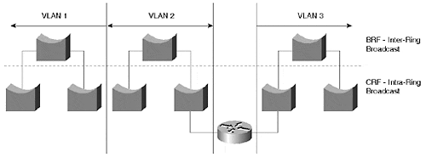
A network may see both the intra- and inter-ring broadcasts. Which one actually describes a VLAN? A VLAN in the Token Ring network includes the TrCRF and the TrBRF. A VLAN exists whenever Token Ring networks must interconnect through a router.

Duplicate Ring Protocol (DRiP)
In a Token Ring environment, each ring has a unique ring number identifying it for source-route bridging. Similarly, in a switched Token Ring, except for the default and backup TrCRFs mentioned earlier, each TrCRF has a unique ring number. If an administrator accidentally misconfigures another TrCRF with the same ring number, shown in Figure 3-11, the Token Ring switching process gets confused.

Figure 3-11 Do not attempt this. Duplicate ring numbers are not allowed on multiple switches.
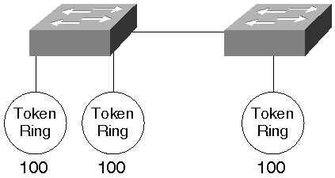
To mitigate the effects of duplicate ring numbers in a switched network, Cisco developed a proprietary protocol to detect them and react accordingly. The Duplicate Ring Protocol (DRiP) sends advertisements with the multicast address 01-00-0C-CC-CC-CC to its neighbors, announcing VLAN information for the source device only. By default, DRiP announcements occur every 30 seconds or whenever a significant configuration change occurs in the network. DRiP announcements only traverse ISL links and are constrained to VLAN1, the default VLAN. The receiving Catalyst then compares the information with its local configuration. If a user attempts to create a Token Ring VLAN that already exists on another Catalyst, the local unit denies the configuration.

Ethernet or Token Ring?
Since IBM introduced Token Ring to the industry, both Token Ring and Ethernet were recognized as candidates for corporate LAN infrastructures. The great debate among LAN specialists focused upon the question, "Which is better—Token Ring or Ethernet?" The answer to that question most often depended on the user application. Early Token Ring limitations offered connection speeds at only 4 Mbps, while Ethernet supported 10 Mbps. It was perceived, therefore, that Ethernet was better because it offered more bandwidth. Later, 16 Mbps Token Ring technology made Token Ring more attractive, but by no means ultimately superior. Some users felt that Ethernet's lack of guaranteed access made it unsuitable for environments such as manufacturing. If an equipment operator needed to control heavy equipment and send start/stop commands over a network, for example, the network administrator wanted to ensure that the command actually would make it to the device. Dangerous conditions could arise if the network lost a control command due to a collision. Because Ethernet offers no such promises in a collision environment, the manufacturing industry tended to select Token Ring. Token Ring promises a user the token at a predictable rate, thereby allowing access to the network to send critical commands. Ethernet could make no such claim; therefore, it was frequently dismissed as a viable networking alternative on the manufacturing floor.
Another factor that caused users to select Token Ring was their mainframe computer type. If the user had IBM equipment, they tended to use Token Ring because much of the IBM equipment had Token Ring LAN interfaces. Therefore, IBM shops were practically forced to use Token Ring to easily attach equipment to their networks.
In an office environment where no guarantees of predictability were necessary, Ethernet found popularity. Ethernet cabling schemes were simpler than Token Ring, and minicomputer manufacturers included Ethernet interfaces in their workstations. As users became more comfortable with Ethernet, network administrators selected it more frequently.
With the introduction of LAN switching technologies, Ethernet now finds application in the manufacturing environment where it previously could not. Switching reduces the size of a collision domain and provides a higher throughput potential that makes it possible to use in manufacturing. Switched Ethernet with ports dedicated to single devices performs equally as well or better than switched Token Ring networks in a similar configuration.

Migrating Token Ring to Ethernet
Many Token Ring users contemplate a migration from Token Ring to Ethernet. In some cases, the motivation is the available bandwidth of Fast Ethernet. Sometimes the motivation is to simplify cabling. But moving an infrastructure from Token Ring to Ethernet involves several considerations. For example, the media cabling type might differ. Many Token Ring systems utilize Category 3 cable (shielded twisted-pair), whereas Ethernet typically uses Category 5 cable (unshielded twisted-pair). Other elements to consider include changing workstations' adapters along with their drivers, performance requirements for existing protocols, and application demands.
A migration plan usually involves phases rather than a comprehensive one-time changeover. Cost, labor availability, and risk drive a migration plan to spread over time. But what should change first? Clients? Servers? Departments? If the cabling infrastructure needs to be upgraded to support the new Ethernet system, the migration may possibly involve geographical issues. This means that the network will change one room or one floor at a time.
If the primary concern is to minimize risk, the migration plan might be a hierarchical approach. Start by moving the backbone to a Fast Ethernet, and bridge or route between the backbone and the distribution segments. Then as the technology proves itself for the applications, move selected devices, such as servers, to the Ethernet system.
Whatever approach you take, be sure to plan it. Migrate—don't mutate—the network.

Summary
Bridging alternatives exist for Ethernet and Token Ring media types. Traditionally, Ethernet uses transparent bridging with the following operations: learning (adding a source address/interface to a bridge table), forwarding out a single interface (known unicast traffic), flooding out all interfaces (unknown unicast, multicast and broadcast), filtering (unicast traffic where the source and destination are on the same interface side), and aging (removing an entry from the bridge table.)
Token Ring usually implements source-route bridging in which the source specifies the path for the frame to the destination. This means the source identifies a sequence of ring/bridge hops. SRT (source-route transparent bridging), another Token Ring bridge method, does both source-route bridging and transparent bridging. Source-route bridging is employed if the frame includes a routing information field. Otherwise, transparent bridging is used.
When connecting transparently bridged segments (Ethernet) to source-routed segments (Token Ring), use routing or translational bridging. If you must use bridging, translational bridging resolves a number of issues in the way that frames are constructed for the different access methods. However, translational bridges must be aware of the protocols to be translated. The best solution, though, is to use routing to interconnect mixed media networks. Chapter 11, "Layer 3 Switching," discusses using routers in a switched environment.
Token Ring switching creates two functions to segment Token Rings: the concentrator relay function and the bridge relay function. In the Catalyst, the Token Ring Concentrator Relay Function (TrCRF) defines which ports belong to a ring. A TrCRF may operate either in SRB or SRT mode. A TrCRF cannot span across Catalysts. The Token Ring Bridge Relay Function (TrBRF) provides Token Ring bridging between TrCRFs. A TrBRF can span across Catalysts to allow ports on different units to communicate through a common bridge.
Source-route switching determines whether a frame may be forwarded within the TrCRF or whether the frame needs to be sent to the TrBRF. The SRS looks for the RII to make this decision. If the RII indicates the presence of a routing information field, it forwards the frame to the TrBRF. Otherwise, the SRS keeps the frame within the TrCRF and uses transparent bridging.

Review Questions
1: | If a RIF is present in a source-routed frame, does a source-route switch ever examine the MAC address of a frame?
2: | To how many VLANs can a TrBRF belong?
3: | The transparent-bridge learning process adds entries to the bridging table based on the source address. Source addresses are never multicast addresses. Yet when examining the Catalyst bridge table, it is possible to see multicast. Why?
4: | Two Cisco routers attach to a Catalyst. On one router you type show cdp neighbor.You expect to see the other router listed because CDP announces on a multicast address 01-00-0C-CC-CC-CC, which is flooded by bridges. But you see only the Catalyst as a neighbor. Suspecting that the other router isn't generating cdp announcements, you enter show cdp neighbor on the Catalyst. You see both routers listed verifying that both routers are generating announcements. Why didn't you see the second router from the first router? (Hint: neither router can see the other.)

